Name: Kenny Chomore Student Number: 225126591
Discipline: Mechanical
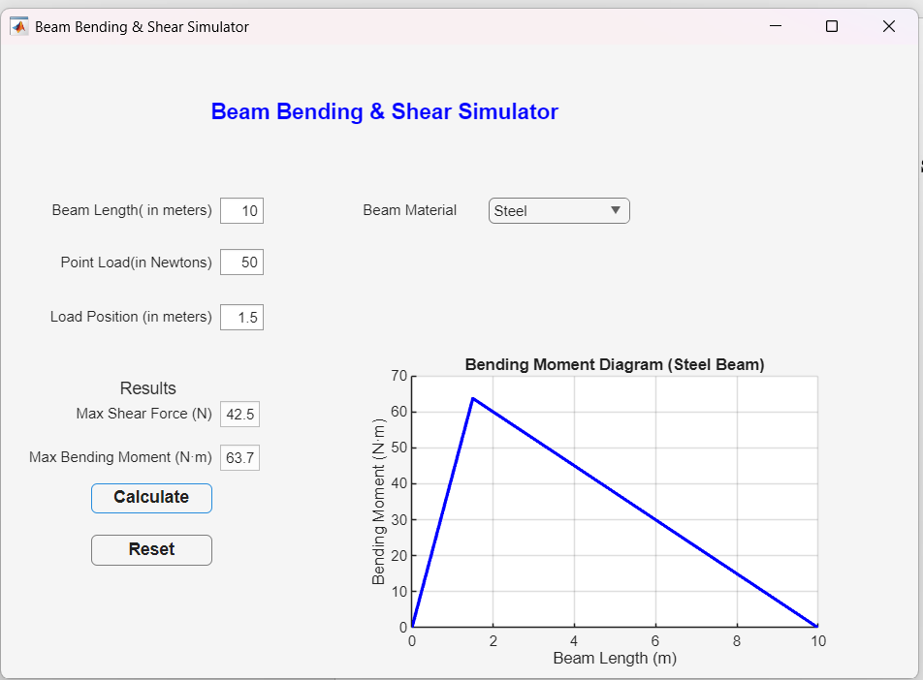
The Beam Bending & Shear Simulator is a MATLAB app that shows how a beam reacts under a point load. Users input the beam's length, weight amount, load position, and select a material like steel or wood. The app then calculates the maximum shear force and maximum bending moment to check the beam's safety. It determines these values by balancing the structural forces and modeling how the end supports hold up the weight. Finally, it plots a visual Bending Moment Diagram that updates its title based on the chosen material. A major challenge was a code error caused by duplicate function names inside the button settings, which blocked calculations. This was solved by cleaning up the background script and removing the extra hidden lines.
